fEngineering Problem
In today’s world, the increasing importance of environmental sustainability has called for engineering solutions to tackle various aspects of this problem. One such aspect is the idea of waste reduction, in particular, energy efficiency and optimisation. In order to design solutions around the idea of optimisation, relevant data must be analysed to find trends and patterns and this project revolves around this concept.
By taking environmental data over time in Monash’s Innovation Labs, this project aims to determine general weekly trends to inform energy usage decisions such as ventilation systems to remove harmful gases, particulates etc, or temperature control systems. This can reduce superfluous energy consumption by creating proactive energy systems to maintain stable environmental conditions. This methodology is applicable to mechanical engineering where operating patterns can be used to optimise mechanical systems, minimising waste energy or material needed for a design.
The intended use of this computational solution is for Monash’s Innovation Labs, as the model and subsequent predictions have been trained on trends and patterns within that area. It is to be used as a guide to program mechanical and electrical systems within the building to optimise when power must be drawn or when it could be conserved to save energy.
However, the scope is limited by the fact that trends within the data may fluctuate depending on larger time groupings, such as yearly trends (e.g. higher usage during engineering team project deadlines or on open days with abnormally high usage by non-Monash people). Furthermore, extended usage over multiple years may miss overall trends over the years where such as increasing numbers of students.
Finally, there is no guarantee that the data is completely accurate and unbiased and thus should not be relied upon solely to determine the patterns and should be checked against real-time data.

Inputs, Output, Data
Inputs Data and Expected Format, Units and Domain
The solution accepts comma separated value (CSV) data from the Monash Smart Infrastructure Occupancy and Environmental Data dataset. The primary inputs are environmental measurements, timestamps and sensor identifiers. The input CSV must contain the following headers: sensorid and jsondata. Environmental measurements and timestamps are stored as a JSON string under the jsondata header, accessed using dictionary-based referencing; therefore, column and JSON property order does not matter but the variable names must match.
The JSON data structure includes multiple variables: Battery (V), Carbon dioxide concentration (ppm), humidity (HR%), Formaldehyde (µg/m3), Pressure (mb), Temperature (°C), Light Volatile Organic Compounds (ppb) and the four particulate matter measurements (PM1, PM2.5, PM4 and PM10) (ppm). For this project, the focus will be on carbon dioxide concentration.
The sensorid field is expected to contain integers, while the timestamps use Unix epoch time. Although the solution imposes no general computational domain on environmental values, measurements are expected to be physically valid, such as generally being non-negative.
User-Defined Parameters
Users can select the environmental variable to analyse and configure parameters for preprocessing, visualisation and neural network training.
Preprocessing: These parameters control data selection and include: environmental variable selection, day bound and minimum number of neighbours for outlier filtering.
Visualisation: These parameters control plot presentation: Marker size, transparency, point connections and maximum points per subplot (plot_max_points).
Neural network: These parameters control neural network training: Training, validation and test weeks; while these parameters control neural network training: minimum points per week; number of epochs; activation function; hidden-layer and neuron configuration; alpha; and random seed (random_state).
Outputs and Intended Use
Neural network predictions: Both environmental measurements and timestamps have the same units as input and are outputted in a dictionary alongside error metrics such as mean absolute error (MAE), root mean squared error (RMSE) and relative RMSE (rRMSE).
Environmental plots: Time-series visualisations (scatterplots) are used to identify trends, fluctuations and potential anomalies. These include: validation error over weeks, selected training, validation and test weeks, expected vs true value, true vs model test week.
Handling Invalid, Missing or Unsupported Inputs
Invalid measurements are filtered during preprocessing. Weeks that do not meet the minimum number of observations required for neural network training are skipped, and a warning message is printed. Unsupported environmental variables or malformed CSV/JSON inputs are ignored with a warning. Initial data visualisation is also used to visually identify invalid measurements before training. Sensors with completely identical readings throughout are warned about, and empty data is also removed. displayed to users to visually check for any outstanding errors and allow them to make a decision on how to handle them

Computational Approach
How the Method Works
This project uses neural network regression to predict environmental trends, focusing on carbon dioxide (CO₂) concentration over time as a proof of concept. Five time-based input functions are passed through interconnected hidden-layer neurons, where learned weights, biases and activation functions transform the inputs into predictions. Prediction errors are calculated against observed values, and backpropagation adjusts the model parameters to minimise these errors during training. Validation data supports hyperparameter selection, while isolated test data evaluates performance on unseen observations.
Why the Method Was Selected
Neural network regression can learn complex, nonlinear relationships without requiring explicitly defined mathematical or physical equations. This makes it suitable for exploring variable environmental trends. Different network architectures and training parameters can also be compared to balance predictive accuracy and computational cost.
Assumptions
Nonlinear relationships: CO₂ trends are assumed to exhibit sinusoidal patterns based on weekly usage visualisations. Activation functions allow the network to learn nonlinear relationships.
Representative data: Historical observations are assumed to contain patterns relevant to future predictions and adequately represent conditions in validation and test datasets.
Settings and Parameters
Input equations: Five functions represent linear, sine and cosine relationships to capture trends over time, including hourly and daily patterns.
Hidden-layer configuration: Five hidden layers containing (32, 32, 32) neurons.
Activation function: Rectified linear unit (ReLU), which introduces nonlinearity by setting negative activations to zero.
Learning rate or regularisation parameter: A learning rate of 0.001 was selected to limit parameter-update sizes and support stable optimisation.
Number of epochs or iterations: 10 iterations were selected for model training.
Random seed: Seed 0 was used to improve reproducibility.
Training, validation and test weeks: Weeks 2–30 were used for training, week 31 for validation, and week 32 for testing. The 2025–2026 period was selected because it contained more observations than the other main grouping.1
Implementation
The dataset is imported and separated into environmental measurements, timestamps and sensor IDs, then grouped by sensor and week. The neural network pipeline was implemented using scikit-learn's MLPRegressor, which learns weights and biases to minimise prediction error. Model architectures and hyperparameters are compared using validation performance and computational time. The selected configuration is then evaluated against the isolated test dataset and through cross-validation.
Limitations
Limited interpretability: Neural networks can be difficult to interpret, limiting insight into how individual inputs influence predictions.
Optimisation limitations: Training may converge to a local minimum, and performance depends on the selected architecture and parameters.
Potential loss of previously learned patterns: Sequential training may overwrite previously learned patterns if earlier information is not preserved.
The model should therefore be interpreted as a data-driven forecasting tool rather than a definitive representation of the physical processes governing environmental conditions.

Alternative solution: Support Vector Regression (SVR)
Accuracy
Support Vector Regression (SVR) was considered as an alternative to neural network regression for predicting trends in environmental data. SVR uses an epsilon-insensitive loss function, which allows a specified range of prediction error to be tolerated without penalising the model. This could be advantageous when analysing CO₂ measurements, where small fluctuations may reflect minor measurement noise rather than meaningful environmental changes, and where the primary objective is to identify larger fluctuations and meaningful trends. This identification is also more useful for environmental systems to act upon, as they have the potential to save the most energy.
However, accuracy depends on selecting appropriate values for epsilon and other hyperparameters. An excessively wide epsilon-tube could overlook meaningful changes, while an excessively narrow tube could cause the model to fit noise. Additionally, too small of a regularisation parameter could prevent the regression from deviating enough to capture important features.
Computational Time and Memory Use
SVR can require substantial memory and be computationally expensive (O(n²)) (Shieh & Kuo, 2010) as the number of training observations increases, particularly when using nonlinear kernels, potentially becoming a bottleneck for large datasets. This is a concern for the project because observations from multiple weeks are required to account for variations in environmental patterns between weeks and the total number of data points is in the tens of thousands. This limits the practicality of using SVR on increasingly large environmental datasets. Ultimately, repeatedly training and evaluating SVR models is impractical compared with the selected neural network approach.
Implementation Complexity
SVR is relatively accessible to implement using Python libraries such as sklearn.svm, which provide built-in regression estimators. It would follow a similar implementation method as the neural network; however, selecting an appropriate kernel and tuning parameters such as epsilon, regularisation strength and kernel-specific settings would require additional experimentation.
Interpretability
SVR provides a mathematically defined regression framework, and its epsilon-tube offers an intuitive explanation of how small prediction errors accepted. However, nonlinear kernel-based SVR models are not necessarily easy to interpret, as their predictions depend on support vectors, kernel functions and fitted parameters and are similarly as much of a black box as neural networks.
Scalability
The principal limitation identified for SVR is its computational scalability. Training time and memory requirements can increase substantially as the number of observations grows, making repeated training across many weeks less practical. Furthermore, a model trained on only a couple of weeks to satisfy computational limitations may capture those weeks’ specific patterns without adequately representing recurring patterns or variations across multiple weeks.
Suitability for the Engineering Application
SVR is potentially suitable for environmental trend prediction because its epsilon-insensitive loss can reduce the influence of minor measurement deviations while retaining larger fluctuations. This could help distinguish meaningful environmental changes from small variations in sensor readings. Nevertheless, the need to train models across multiple weeks and compare numerous parameter configurations makes computational efficiency an important requirement. The anticipated time and memory costs of SVR therefore make it less attractive for this project's workflow, particularly as the dataset grows. Consequently, neural network regression was selected as the primary approach, while SVR remained a potential alternative for future comparison.

Validation Method
What Was Validated
Validation assessed whether the neural network produced predictions that accurately represented the general trends in CO₂ concentration over time, and whether these trends generalised to unseen weeks.
Following training, predicted trends were compared against withheld test data. Additional cross-validation across multiple datasets was used to examine whether model performance remained consistent across different weeks. RMSE and rRMSE were main validation metrics to quantitatively measure how closely the neural network’s generalisation followed the true weekly pattern. Visualisation also provided a qualitative method for validating whether the model reproduced the overall shape and major fluctuations of the data consistent with the underlying trends across weeks. A fixed random seed was used to improve reproducibility when comparing configurations.
Why the Validation Method Is Appropriate
Withheld test data provides an independent basis for assessing model performance because these observations are not used to fit the model. This helps indicate how well the model generalises to environmental data it has not previously encountered. Cross-validation across multiple weeks provides further evidence by assessing performance under different weekly conditions. This is particularly relevant because environmental measurements may fluctuate between weeks, even when their overall trends remain similar. It is also important as it helps check how well the model generalises on multiple weeks to check if any outcome’s success is not simply an anomaly. Combining quantitative metrics with visual inspection is appropriate because a model may achieve a relatively low numerical error while failing to reproduce important features of the observed trend. Visual comparisons therefore complement numerical evaluation when assessing the engineering usefulness of the predictions.
Metrics and Acceptance Criteria
Root mean squared error (RMSE): Measures the magnitude of prediction errors, penalising larger errors more heavily. Lower RMSE was prioritised when comparing candidate models.
Relative root mean squared error (rRMSE): Expresses prediction error relative to a reference scale as a percentage, allowing performance to be assessed in relation to the magnitude or variability of the observed data. A value of 10% was set as the acceptance criterion.
Mean absolute error (MAE): Measures the average absolute difference between predicted and observed values.
Visual inspection of predicted and observed CO₂ trends was also used to assess whether the model
What the Validation Cannot Establish
Validation primarily establishes agreement between predicted and observed measurements within the evaluated datasets. Although the validation results provide evidence that the model reproduces expected environmental trends, they cannot establish the absolute accuracy of the predictions in a real-world scenario. Furthermore, any potential biases in the data could also be captured by the model and remain undiscovered when validating against the same biased data. The results are also limited by the quality and representativeness of the input data. Undetected sensor faults, unusual environmental conditions or differences between training and future data may affect performance in practical applications.

Results
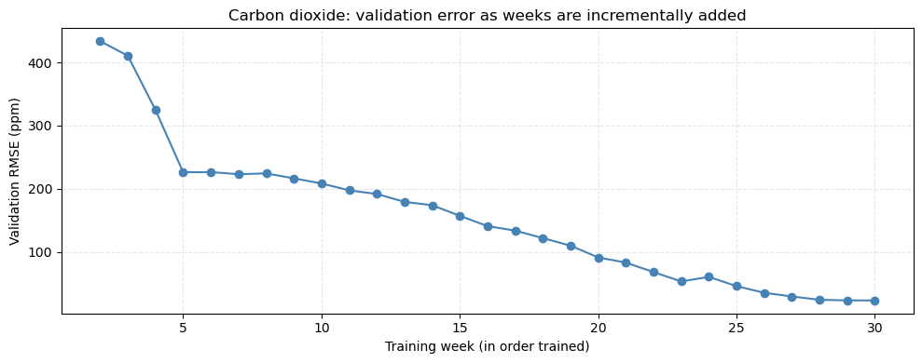
Figure 1. Graph of validation error over time as the model is trained over multiple weeks.
Evidently, the graph is decreasing with additional training weeks, indicating that the model is learning the trends between weeks.
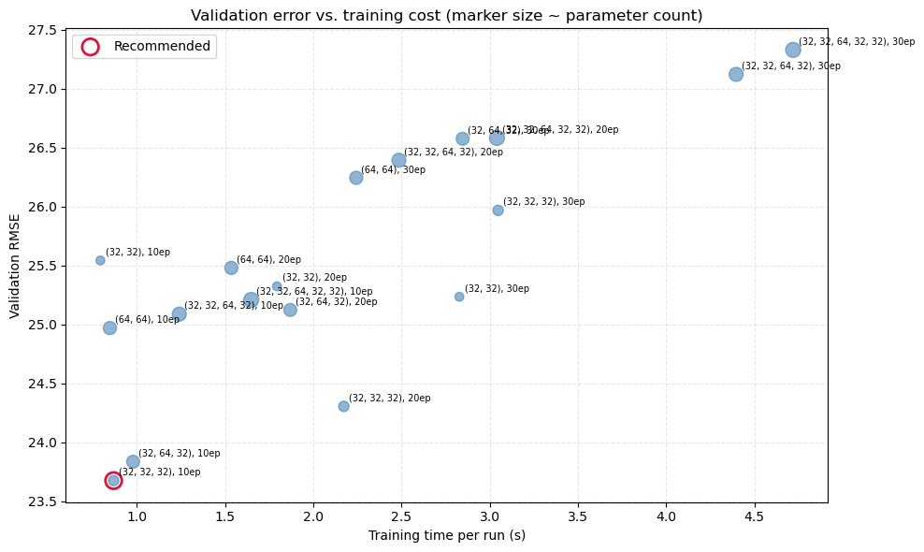
Figure 2. Graph of validation error against time taken to run for different neural network structures and epochs.
This graph was used to compare different neural network architectures and number of epochs using the validation data from week 31. The lowest error was (32, 32, 32) with 10 epochs and was much faster compared to the next best result. Larger networks seemed to have lower validation RMSE on average and a slight effect on training time while the number of epochs had a large influence on training time but very little effect on validation RMSE.
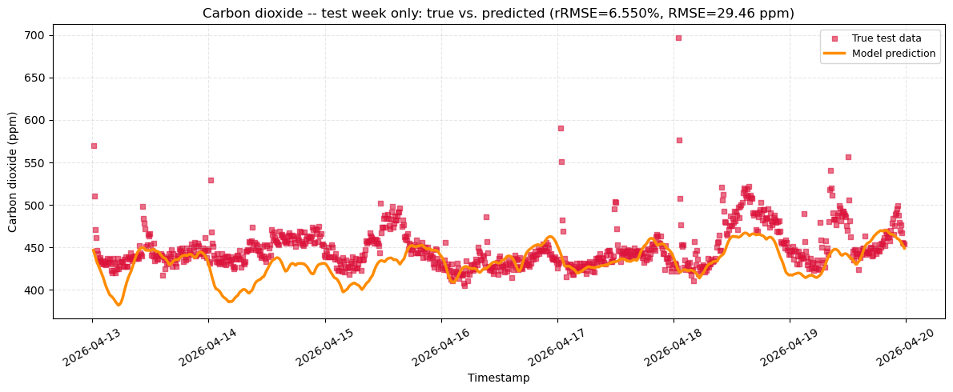
Figure 3. Graph of final test week: model prediction vs true test data.
This graph illustrates the final selected model against the true test data for week 32. The rRMSE is quite low, 6.6%, which is less than the acceptance criterion of 10%. This indicates a good predictive performance. Qualitatively, the graph follows most of the cyclical trends.
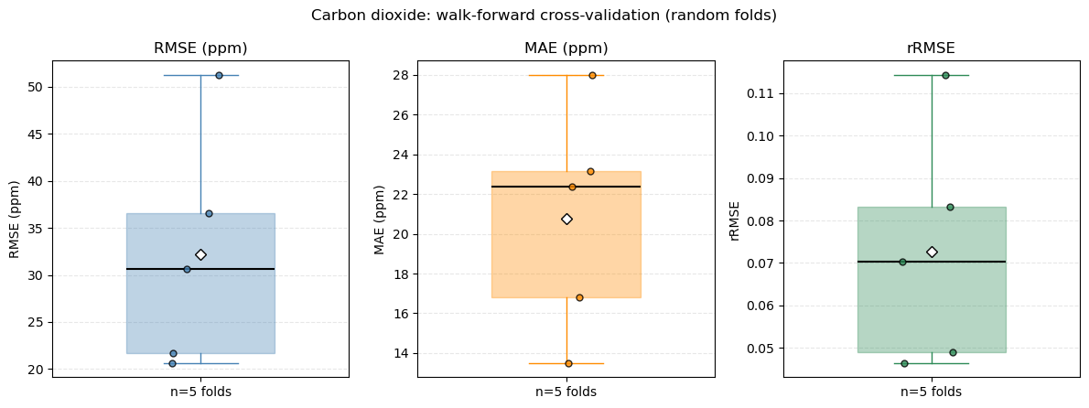
Figure 4. Boxplots of 5-fold random cross validation.
The median rRMSE is around 7%, with an IQR of around 3%. This indicates that the model should perform quite well on most unseen test data, as 4 out of 5 of the results are within the 10% acceptance criteria.
Consequently, the model was considered suitable based on its quantitative validation metrics, visual agreement with observed trends and performance on withheld data. These findings support its use as a tool for predicting general environmental trends, but do not establish that every individual prediction is physically accurate.

Optimisation Work
Solution Accuracy
Optimisation aimed to achieve an acceptable balance between prediction accuracy and computational efficiency. Different neural network configurations were evaluated by comparing RMSE with training time per run, with the number of hidden layers and neurons adjusted to identify configurations that maintained predictive performance without unnecessary computational overhead. The selected solution achieved an error of approximately 6.6%.
Computational Runtime and Memory Requirements
Optimisation was conducted throughout development, particularly when execution times exceeded acceptable limits of several minutes. Once the code operated successfully, further improvements targeted redundant function calls, repeated execution of overlapping code and unnecessary data processing and when existing results could be reused. Vectorised operations were used in preference to Python loops due to their high efficiency. The final implementation achieved a total runtime of approximately 15.5 seconds (including cross-validation), and was tuned by the hyperparameter comparison graph to less than 2 seconds which was considered an acceptable balance between accuracy and execution time.
Memory efficiency was considered to ensure the solution could run on a laptop without unnecessary memory consumption. Redundant data copying and the repeated allocation of intermediate datasets were identified as potential sources of overhead. Therefore, pointers were implemented to reference a master dataset to avoid this. Visualisation was also optimised through data thinning, reducing the number of plotted observations while retaining the full dataset for training, validation and testing. This reduced plotting overhead without sacrificing the data available for model development.
Model Settings
Hyperparameter optimisation focused on the number of hidden layers and neurons, as well as the number of epochs to train per week, as these directly influence model complexity and computational cost. Multiple configurations were evaluated, with their RMSE and execution times compared to identify an efficient architecture. Reducing the number of layers or neurons can decrease training time and resource requirements, although excessive simplification may reduce the model's ability to capture complex environmental patterns. It was found that a larger number of layers performed better, being able to capture deeper complexities and patterns underlying the data.
Scalability
Scalability was considered because the solution must accommodate environmental observations across multiple weeks. The implementation groups observations by week and allows additional weekly datasets to be incorporated into the analysis. However, adding more weeks may have unintended effects on the accuracy of the solution, such as overgeneralising with slightly different features per week that contradict each other, resulting in a more linear generalisation.
Trade-offs
The optimisation process involved balancing prediction accuracy, execution time and memory consumption. Increasing network complexity or number of epochs per training week may improve the model's ability to represent environmental trends, but can also increase training time and resource requirements. Conversely, reducing complexity improves efficiency but may result in underfitting and inaccurate results. Overall, optimisation focused on removing unnecessary computation and selecting an appropriately sized model rather than maximising predictive accuracy at any computational cost.

Limitations and Lessons Learned
As the models were trained on data collected in a noisy, uncontrolled environment, they may have learned some noise alongside the underlying trends. Therefore, balancing accurate trend prediction with avoiding noise remains a potential limitation. The neural network model also creates a generalisation, providing trends in the data without an explanation of what could have caused the trends.
Throughout this project, the importance of balancing the trade-off between model accuracy and computational efficiency, timing and resource use, was highlighted. To support this, code had to be refined where possible to ensure it operated within computational limits. Furthermore, implementing effective data cleaning and validation helped prevent erroneous patterns from being captured.
Another lesson learned is that model selection should reflect dataset size and computational requirements. For example, while Support Vector Regression (SVR) may be suitable for smaller datasets, the larger dataset used in this project made it too computationally expensive. Finally, maintaining well-documented and regularly updated code was essential for understanding the implementation, tracking changes, and making further improvements efficiently.

AI Use
AI Tools Used and Tasks Used For
Anthropic’s Claude Sonnet 5 was the primary AI tool, with Gemini 3 used as a secondary tool to compare outputs and identify simplifications. Claude was preferred for its accuracy, generating and debugging Python code for most functions, adding documentation and providing technical explanation. Gemini was used to compare outputs and helped remove unnecessary complexity while ChatGPT was used to finalise and consolidate the report.
Level of AI Contribution and Decisions Retained by the Student
AI contributed substantially to code generation and modification. However, the student designed the project concept, model, methodology, required functions, workflow, determined component interactions and selected model parameters. The student retained responsibility for technical direction, critical analysis and verification through iterative testing and refinement. This includes, selecting the model and training, validation and testing weeks, choosing the final hyperparameters and assessing convergence and runtime, selecting evaluation metrics and visualisations, evaluating prediction accuracy against project objectives, determining acceptable limitations and necessary refinements, deciding which AI-generated features to retain, simplify or remove. These decisions required independent judgement rather than uncritical acceptance of AI recommendations.
Verification of AI-Generated Material
All AI-generated code was tested in an isolated Spyder environment before integration and uploading to GitHub. Outputs were examined for correct timestamp processing, data handling, visualisation and plausible predictions. Unexpected behaviour was investigated through further prompting or manual modifications.
Rationale for Using AI
AI was used to reduce time spent on repetitive coding, syntax corrections and formatting, allowing greater focus on MMA3001 numerical methods and their application. The project also developed skills in prompt refinement and output verification, an increasingly important skill as AI becomes a new tool that engineers can use to streamline their work process.
AI Errors, Limitations and Unhelpful Suggestions
AI sometimes misunderstood the data structure and modelling objectives. For example, it accumulated CO₂ values across weeks instead of incrementally adjusting model weights, misinterpreted dates and treated timestamps as continuous inputs when the objective was to identify weekly patterns.
Other issues included excessive training and cross-validation runtimes, excessive observation removal during deduplication and overcrowded plots that obscured trends. AI also introduced redundant functionality and unnecessary complexity.
Impact of AI Use on Understanding and Workflow
AI shifted much effort from writing code line by line towards directing, evaluating and refining its implementation. The student developed skills in writing precise prompts, specifying expected outputs and diagnosing problems systematically. Runtime optimisation also encouraged the identification of inefficient operations and their replacement with array-based alternatives.
Comparing Claude and Gemini reinforced the importance of critically evaluating outputs rather than relying on a single tool. Maintaining an updated, documented codebase also helped the student understand and modify individual components. Overall, the project demonstrated that AI can accelerate implementation, but engineering responsibility remains with the engineer, who must verify functionality, assess limitations and make informed technical decisions.

References
Shieh, H.-L., & Kuo, C.-C. (2010). A reduced data set method for support vector regression. Expert Systems with Applications, 37(12), 7781–7787. https://doi.org/10.1016/j.eswa.2010.04.062

